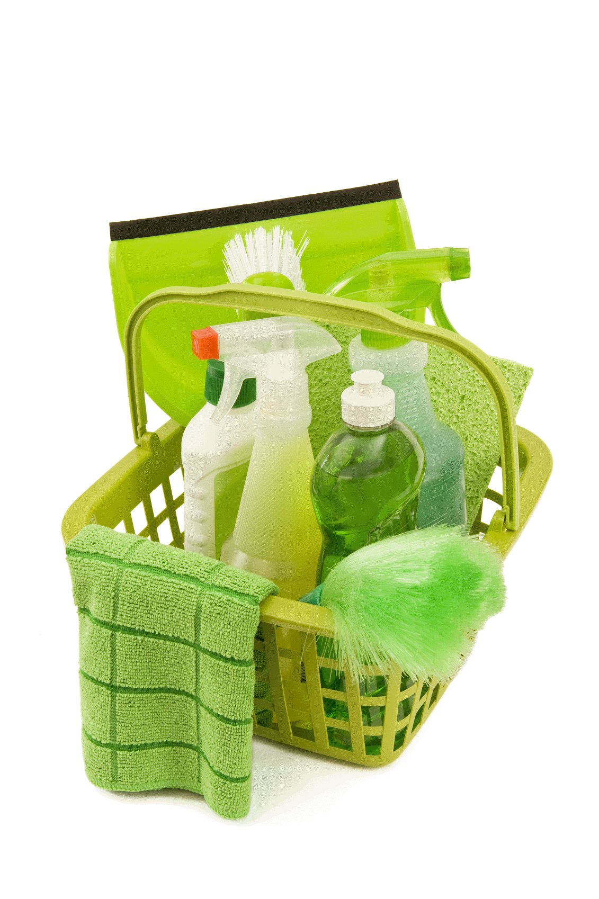

Staff Training Manual
Health and Safety
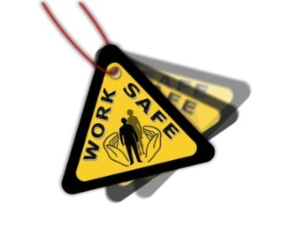
- Only use cleaning materials and equipment supplied by Eco-Clean, you must not use or bring unauthorised products.
- When using electrical machines and you are required to move the plug from one socket to another, switch off the machine, and switch off the socket before removing the plug.
- Do not unplug ANY plugs onsite.
- Report any defective equipment to your manager without delay; do not attempt to repair any electrical equipment yourself.
- Further to the interests of your health and safety, you must not intentionally or recklessly interfere with or misuse any equipment or materials provided to you.
- Do not pull any vacuums or electrical equipment by the electrical lead.
- Report all accidents to your manager
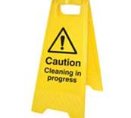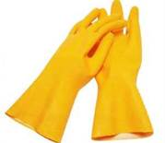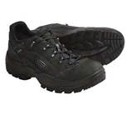
Please ensure for your own safety that you always use the appropriate Personal Protective Equipment (PPE).

Colour Coding

Colour coding is used to unsure that cross contamination from one area to another does not occur, the following coloured cloths must be used:-
RED – Toilet & urinals
BLUE - General areas
GREEN – Food preparation areas (Kitchen)
For example: when cleaning toilets and urinals do not confuse the red cleaning cloth with either the blue or the green clothes, ONLY USE the RED toilet cloth for carrying out this task.

Risk Assessment
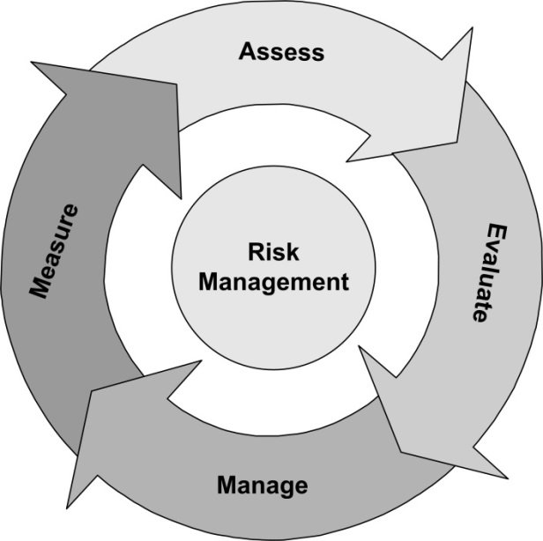

It is the duty of all employees to report any hazards that they identify whilst carrying out their duties to their manager immediately, any risk associated with the hazard will be assessed and measure will be taken to eliminate or reduce the likelihood of an accident or injury being caused.

Manual Handling
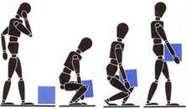
The Individual
- Check whether you need to move the item at all.
- Never attempt to lift or move items unless you have been given permission to do so.
- Ensure that you are capable of undertaking the task.
The Environment
- Ensure that the surrounding is safe.
- Check for uneven, wet or damaged floors.
- Remove any obstructions.
- Ask for help if the load is too heavy for one person.
The Task
- Carry loads close to the body.
- Avoid awkward movements such as reaching and twisting.
- Limit the distance that you need to carry the load.
- Ensure the load you are carry does not restrict your vision.

Dusting, Damp Wiping and Washing
- Warning signs must be used
- Personal Protective Equipment (including protective gloves) must be worn for this task
- Do not allow multi-surface cleaner to be sprayed onto the floor (over spray)
Equipment
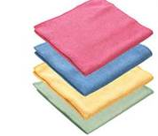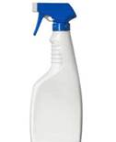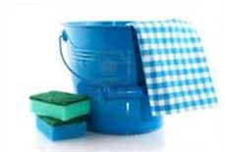
Operating Procedures
- Place warning signs (where applicable).
- Ensure you are wearing your personal protective equipment.
- Assemble equipment and check condition for use
- Dusting: use a dry duster. Dust vertical surfaces from the top down, overlapping strokes and refolding the duster if necessary, drawing dust from any corners.
- Damp Wiping: prepare cleaning solution according to manufacturer’s instructions. Wipe surface with a damp BLUE cloth using smooth strokes. Spray cleaning solution onto BLUE cloth and not directly onto the surface being cleaned.
- Washing: Apply cleaning solution to the BLUE cloth, remove dirt wiping systematically. Rinse with clean water and wipe dry with a clean cloth.
- Check and clean all equipment after use for safety and condition, ready for the next job.

Mopping and Dry Sweeping
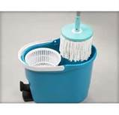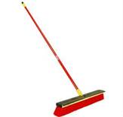

- Place warning signs (where necessary)
- Remove any moveable objects from the floor area.
- Start at the furthest point from the exit and work systematically back towards the exit.
- Use a dust pan and brush to remove waste and place into a black refuse bag.
Mopping techniques
- Always keep the bucket behind the line of work.
- Do not remove warning signs until the floor is completely dry.

Suction Cleaning (Hoovering/Vacuuming)
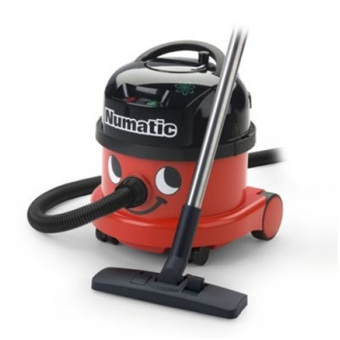
- Check equipment for safety
- Pick up any large or sharp objects by hand (use protective gloves for sharp objects) before starting to vacuum.
- Vacuum the area systematically, giving more attention to heavy traffic areas, edges and corners.
- Keep the cable behind you, do not overstretch the cable
- Switch off the power before unplugging, recoil the cable to the machine
- Store equipment safely away in its allocated place.

The Cleaning of Stairs, Balustrades and Handrails
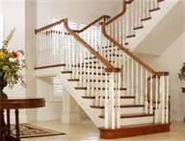

- Warning signs must be used on all landings.
- Whilst cleaning the handrail/balustrades keep both feet on the ground at all times, do not lean over or stretch.
- All equipment must be kept safely to one side of the landing so not to cause obstruction to others.
- Do not place vacuum cleaners or buckets on the stairs.
- Ensure all electrical cables do not obstruct the stairs.
- All surfaces must be left as dry as possible, wipe any water spillages immediately.

The Cleaning of Toilets, Urinals and Washrooms
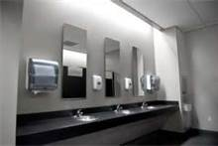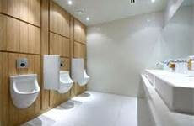

- Place warning signs and ventilate if appropriate.
- Put on Personal Protective Equipment (PPE).
- Assemble equipment and check for safety.
- Apply detergent to the inside of the toilet bowl, wait 5 minutes.
- With a BLUE cloth clean sinks, cisterns and handles.
- Scrub the toilets thoroughly with the toilet brush, particularly paying attention to any stains, water lines and under rims.
- With a cleaning agent and RED colour coded cloth wipe outside and around the toilet bowls, urinals & pipework.
- Clean the toilet seat lids, top, underneath and hinges, work from clean to dirty.
- Dry toilet seat and close lid.
- Check and replenish all consumables.
- Check and return all cleaning equipment to allocated storage cupboard.

